**Practical No. 5. HANDLING MULTIPLE WINDOWS & FRAMES USING SELENIUM**

**Date: __________________**

**Aim:**

To learn how to handle multiple windows, frames and modals using selenium.

**Theory:**

**How to handle Selenium multiple window using Webdriver**

In automation, when we have multiple windows in any web application, the activity may need to switch control among several windows from one to other in order to complete the operation.

After completion of the operation, it has to return to the main window i.e. parent window in Selenium.

**WindowHandle:**

*It is a unique identifier that holds the address of all the windows.* Think of it as a pointer to a window, which returns the string value. It is assumed that each browser will have a unique window handle. This window handle function helps to retrieve the handles of all windows.

In Selenium web driver there are methods through which we can handle multiple windows.

**Driver.getWindowHandles();**

To handle all opened windows by web driver, we can use “Driver.getWindowHandles()”. This method helps to get the handles of all the windows opened and then we can switch window from one window to another in a web application. Its return type is Iterator<String>.

**Driver.getWindowHandle();**

When the site opens, we need to handle the main window by driver.getWindowHandle(). This method helps to get the window handle of the current window. Its return type is String.

**set:**

This method helps to set the window handles in the form of a string.

set<string> set= driver.get.windowhandles()

**driver.switchTo()**

This method helps to switch between the windows

**action:**

This method helps to perform certain actions on the windows

**How to handle frames in Selenium Webdriver**

Frames in HTML can be used to divide a web-page vertically or horizontally. iFrames is mainly used for displaying external content on a target web page, for example, an advertisement for any online programming course on a web page. An iframe is also known as the inline frame. It is a tag used in HTML5 to embed an HTML document within a parent HTML document. An iframe tag is defined using <iframe></iframe> tags.

It is possible to identify the iframes on a web page in two ways:

* Right-click on the specific element and check all the options. If you find an option like This Frame, view Frame source or Reload Frame, it means the page includes frames.
* Similar to the first step, right-click on the page and click on View Page Source. On the page source, search for “iframe-tags”. If you find any iframe tags, it means the page includes iframes.

To interact with any web element present within any frame, one needs to switch to that particular frame. This allows the user to identify elements present on that page and write tests accordingly.

QAs can switch between frames using the **Switch.frame()** function. The switch function can be implemented using three different locators: By.index, By.id, By WebElement. Refer to the commands below:

**By Index**

driver.switchTo().frame(1);

Switches to the frame with index number 1

**By Id or Name**

driver.switchTo().frame(“resultframe”);

Switches the frame where the value of id attribute is resultframe

**By Web Element**

WebElement iframeElement = driver.findElement(By.id("resultframe"));

driver.switchTo().frame(iframeElement);

The WebElement command above identifies the web element and then passes it through the iframe element object.

**How to handle modals in Selenium WebDriver?**

A Modal Dialog Box (also referred to as Bootstrap Modal Window) is built in Bootstrap Framework, due to which it gets displayed on top of your current page. Due to this, modal boxes need to be interacted with first before moving to the current webpage. Switching is not necessary for modals.

**Implementation**

1. Open “flight_reservation.html” and write a script to handle frames and print the heading of the page in each frame.

**Code:**

**package pkg;**

**import org.openqa.selenium.By;**

**import org.openqa.selenium.WebDriver;**

**import org.openqa.selenium.WebElement;**

**import org.openqa.selenium.firefox.FirefoxDriver;**

**public class IframeDemo {**

**public static void main(String[] args) throws InterruptedException {**

**// TODO Auto-generated method stub**

**System.setProperty("webdriver.gecko.driver","G:\\Selenium_setup\\geckodriver.exe");**

**// Web driver for FireFox**

**WebDriver driver = new FirefoxDriver();**

**// open train_reservation page**

**driver.get("file:///G:/Flight_Reservation/flight_reservation.html");**

**// switch to iFrame - 1**

**driver.switchTo().frame(0);**

**// Locate Heading in iFrame One**

**WebElement headingInIfrm1 = driver.findElement(By.id("heading1"));**

**// Display Heading in iFrame One**

**System.out.println("Heading inside Iframe-1: "+ headingInIfrm1.getText());**

**// returns you back to main window directly**

**driver.switchTo().defaultContent();**

**// Switch to iFrame-2**

**driver.switchTo().frame("IF2");**

**// Locating Elements in iFrame - 2**

**WebElement headingInIfrm2 = driver.findElement(By.id("heading2"));**

**// Display Heading in iFrame - 2**

**System.out.println("Heading inside Iframe-2: "+ headingInIfrm2.getText());**

**// switch to iFrame-3 from iFrame-2**

**driver.switchTo().frame(0);**

**// Locating Elements in iFrame - 2**

**WebElement headingInIfrm3 = driver.findElement(By.id("heading3"));**

**// Display Heading in iFrame - 2**

**System.out.println("Heading inside Iframe-3: "+ headingInIfrm3.getText());**

**// Switch to default**

**driver.switchTo().defaultContent();**

**// Wait for 5 seconds**

**Thread.sleep(5000);**

**driver.quit();**

**}**

**}**

**Output:**

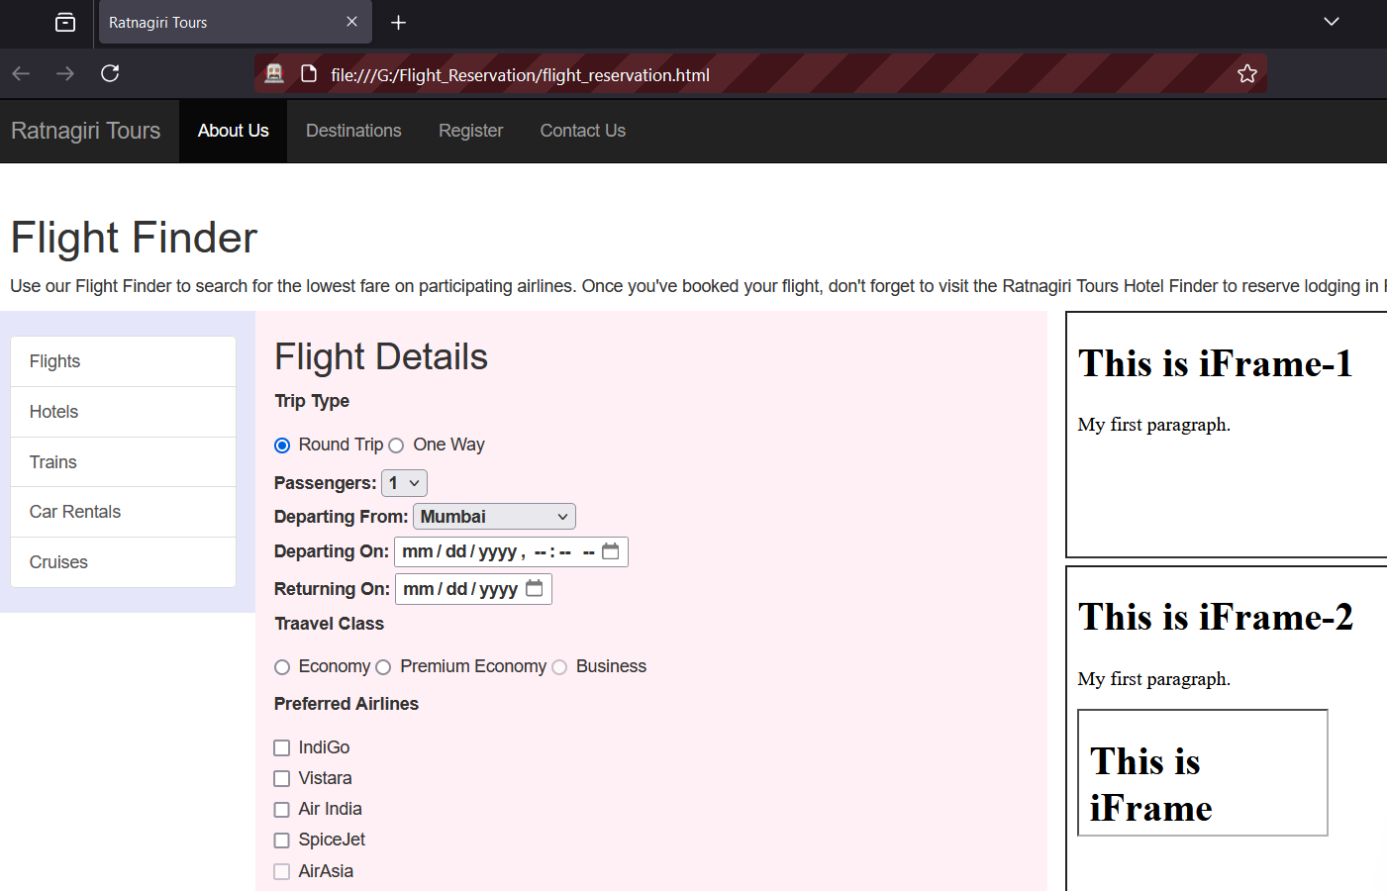

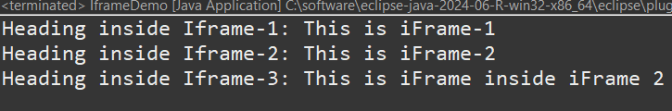

1. Open [*https://demoqa.com/browser-windows*](https://demoqa.com/browser-windows) and write a script to handle multiple windows that opens after clicking the button “New Window” and print the heading on that new window.

**Code:**

**package pkg;**

**import org.openqa.selenium.By;**

**import org.openqa.selenium.WebDriver;**

**import org.openqa.selenium.firefox.FirefoxDriver;**

**import java.util.Set;**

**public class HandleMultipleWindows {**

**public static void main(String[] args) throws InterruptedException {**

**// Set the path of the geckodriver (change the path as per your system)**

**System.setProperty("webdriver.gecko.driver","G:\\Selenium_setup\\geckodriver.exe");**

**// Create a new instance of the Firefox driver**

**WebDriver driver = new FirefoxDriver();**

**// Open the URL**

**driver.get("https://demoqa.com/browser-windows");**

**// Store the current window handle (main window)**

**String mainWindow = driver.getWindowHandle();**

**System.out.println("Main Window Handle: " + mainWindow);**

**// Click on the button that opens a new window**

**driver.findElement(By.id("windowButton")).click();**

**// Get all window handles**

**Set<String> allWindowHandles = driver.getWindowHandles();**

**// Loop through all window handles**

**for (String windowHandle : allWindowHandles) {**

**if (!windowHandle.equals(mainWindow)) {**

**// Switch to the newly opened window**

**driver.switchTo().window(windowHandle);**

**// Wait for a few seconds to ensure page loads**

**Thread.sleep(2000);**

**// Get and print the heading from the new window**

**String heading = driver.findElement(By.id("sampleHeading")).getText();**

**System.out.println("Heading on the new window: " + heading);**

**// Close the new window**

**driver.close();**

**}**

**}**

**// Switch back to the main window**

**driver.switchTo().window(mainWindow);**

**// Close the main window**

**driver.quit();**

**}**

**}**

**Output:**

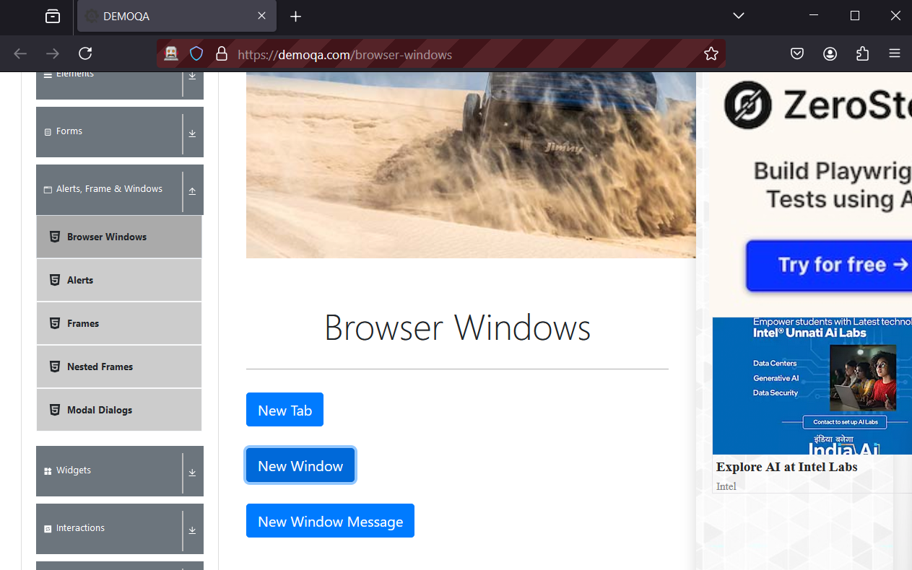

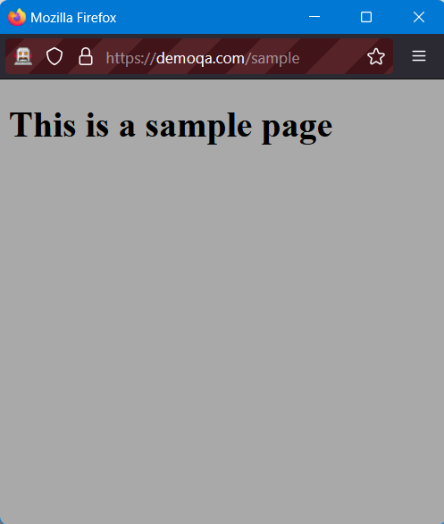

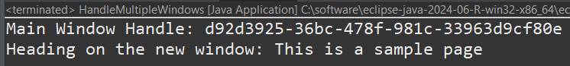

1. Open “flight_reservation.html” and write a script to handle popup window that opens after clicking on “Hotels” Hyperlink and print title of the popup window and heading on that page.

**Code:**

**package pkg;**

**import java.util.Set;**

**import org.openqa.selenium.Alert;**

**import org.openqa.selenium.By;**

**import org.openqa.selenium.WebDriver;**

**import org.openqa.selenium.WebElement;**

**import org.openqa.selenium.firefox.FirefoxDriver;**

**public class HandlePopUp {**

**public static void main(String[] args) throws InterruptedException {**

**// TODO Auto-generated method stub**

**System.setProperty("webdriver.gecko.driver","G:\\Selenium_setup\\geckodriver.exe");**

**// Web driver for FireFox**

**WebDriver driver = new FirefoxDriver();**

**driver.get("file:///G:/Flight_Reservation/flight_reservation.html");**

**String mainWindow = driver.getWindowHandle();**

**WebElement btn = driver.findElement(By.linkText("Hotels"));**

**btn.click();**

**Thread.sleep(5000);**

**// Get all window handles**

**Set<String> allWindowHandles = driver.getWindowHandles();**

**// Loop through all window handles**

**for (String windowHandle : allWindowHandles) {**

**if (!windowHandle.equals(mainWindow)) {**

**// Switch to the newly opened window**

**driver.switchTo().window(windowHandle);**

**// Wait for a few seconds to ensure page loads**

**Thread.sleep(2000);**

**// Get and print the heading from the new window**

**String heading = driver.findElement(By.id("sampleHeading")).getText();**

**System.out.println("Heading on the new window: " + heading);**

**// Close the new window**

**driver.close();**

**}**

**}**

**Thread.sleep(5000);**

**driver.quit();**

**}**

**}**

**Output:**

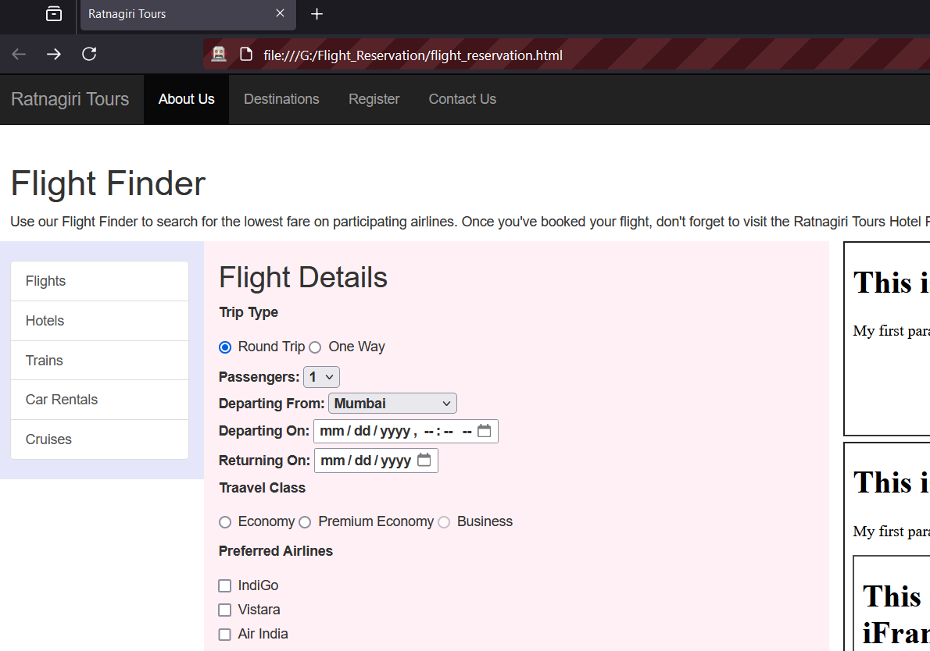

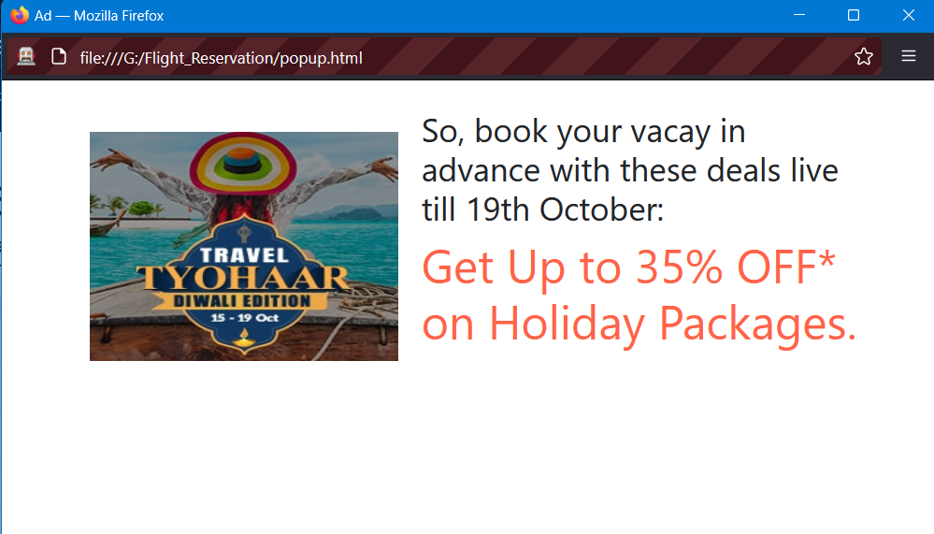



1. Open “hotel_search.html” page and handle modals that appear after clicking on buttons on that webpage.

**Code:**

**Output:**

**Conclusion:** Learnt to handle multiple windows, frames and modals in Selenium.

**After performing this Practical/lab, students are expected to answer following questions**

1. What is iframe?
2. What is Window handle?
3. What is switchTo() method?